Assignment: Understanding Art, Design, and Decoration
Subject: Graphic Design | Simple English | Ready-to-submit assignment

1. Identify 10 designs from daily life
Take photos or screenshots of these examples from your daily life and classify them as Art, Design, or Decoration.
No. | Example | Classification | Explanation
1 | Instagram post | Design | It uses images, colors, and text to share information and attract people.
2 | Movie poster | Design | It combines typography, images, and colors to promote a movie.
3 | Wall painting | Art | It expresses the artist's creativity, emotions, and ideas.
4 | Decorative lights | Decoration | They make a room or place look attractive.
5 | Coca-Cola bottle packaging | Design | Its colors, logo, and shape help people recognize the brand.
6 | Rangoli | Art | It shows creativity through patterns, shapes, and colors.
7 | Website homepage | Design | It organizes information and helps visitors navigate the website.
8 | Birthday party balloons | Decoration | They make the celebration area look beautiful and festive.
9 | Mobile app icons | Design | Icons help users recognize apps and understand their functions.
10 | Decorative photo frame | Decoration | It enhances the appearance of a photo or room.
Note: These are sample classifications. Some examples can belong to more than one category depending on their purpose.

2. Graphic design in 3 daily-use apps

App 1: Instagram

Place 1: App logo
- Elements: Gradient colors, camera symbol, rounded shape.
- Purpose: Makes Instagram easy to recognize and helps build brand identity.
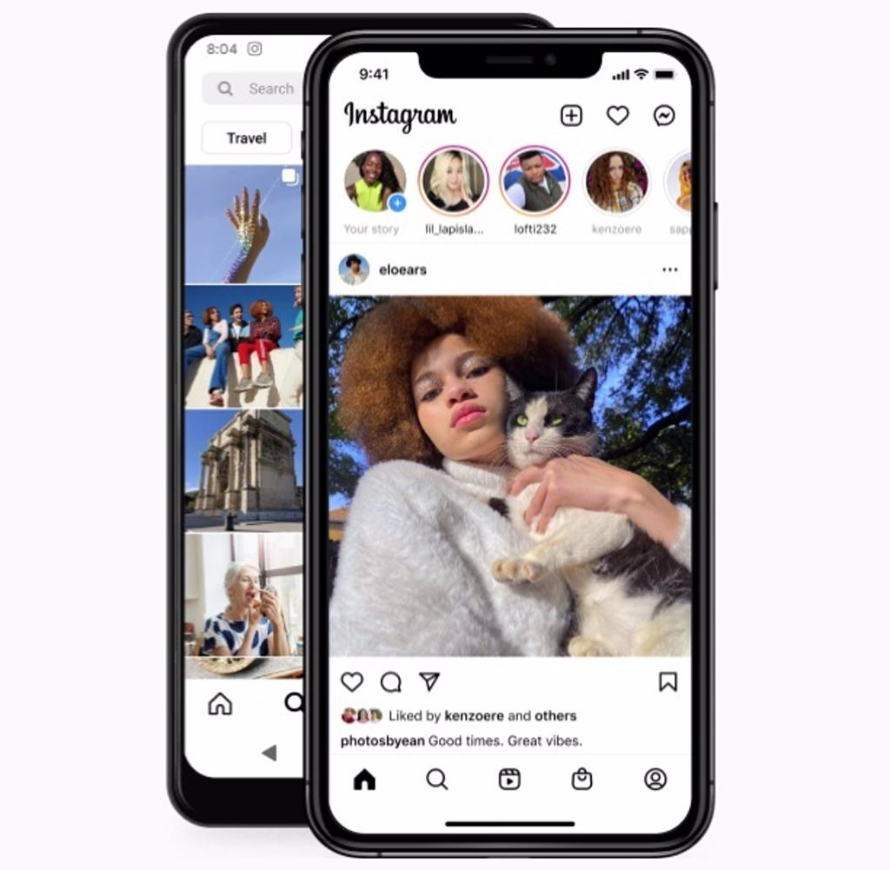
Place 2: Home feed and Stories
- Elements: Circular profile pictures, icons, white background, and organized layouts.
- Purpose: Helps users view posts, watch Stories, like content, and share photos easily.

App 2: Zomato

Place 1: Logo and brand colors
- Elements: Red color, simple logo, and clear typography.
- Purpose: Creates brand recognition and makes the app easy to identify.
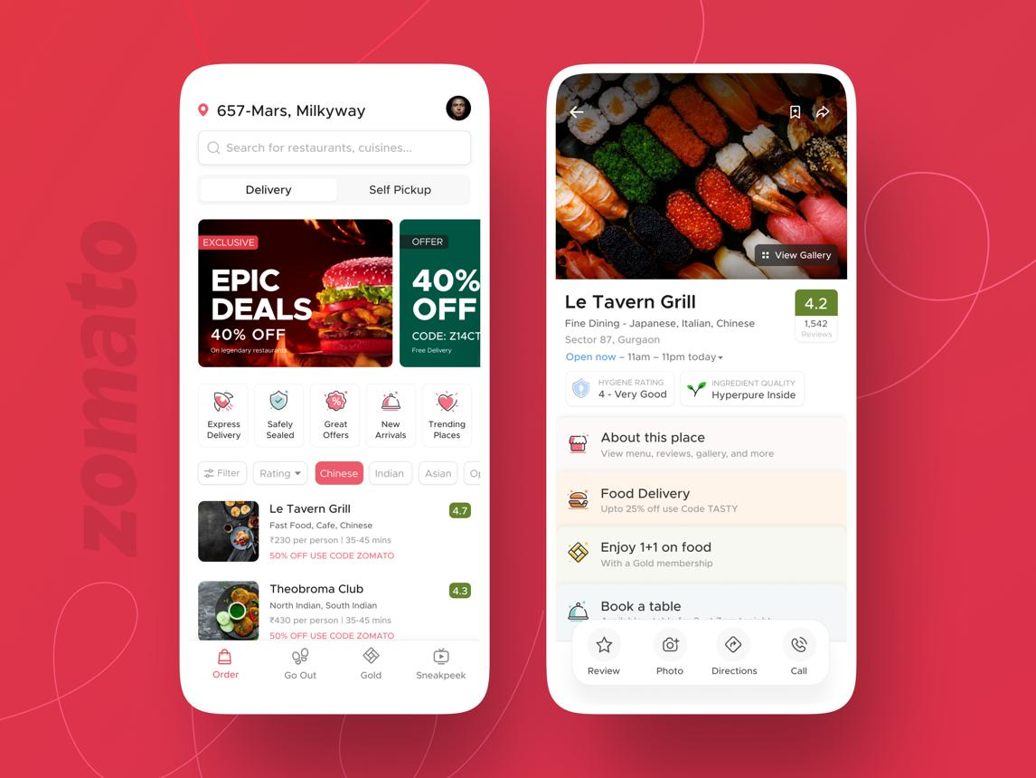
Place 2: Restaurant listings
- Elements: Food photographs, ratings, prices, and organized cards.
- Purpose: Helps users compare restaurants and choose food easily.

App 3: Paytm

Place 1: App logo
- Elements: Blue color, simple lettering, and a recognizable wordmark.
- Purpose: Helps users identify the brand quickly.
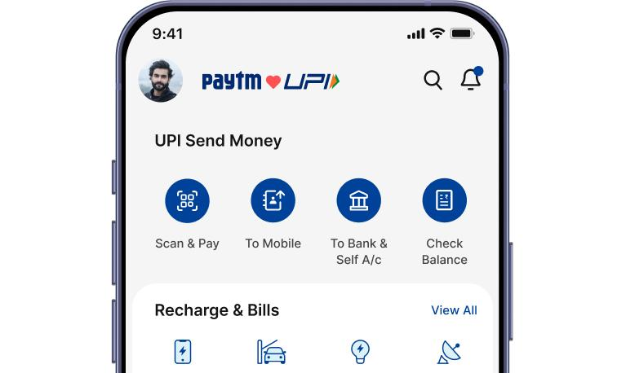
Place 2: Payment dashboard
- Elements: Icons, buttons, clear labels, and a structured layout.
- Purpose: Helps users find features such as scanning QR codes, sending money, and checking transactions.

3. Comparison table: Art vs Design vs Decoration
Comparison point | Art | Design | Decoration
1. Main purpose | Expresses feelings and creativity. | Solves a problem or communicates a message. | Makes something look beautiful.
2. Focus | Imagination and personal expression. | Function, usability, and communication. | Appearance and visual appeal.
3. Example | A creative digital painting. | A mobile app login screen. | Decorative patterns on an app background.
4. User benefit | Provides enjoyment or emotional meaning. | Helps users understand and use a product. | Makes the product or space more attractive.
5. Success measure | Emotional impact and artistic expression. | How clearly and effectively it works. | How pleasing the appearance is.
6. Digital example | An original digital illustration. | A website banner promoting a sale. | Sparkles or ornamental shapes added around the banner.
Conclusion: Art expresses creativity, design communicates a message or solves a problem, and decoration improves appearance. They can also be used together in one digital product.

4. Analysis of a well-designed social media post or digital ad

it.wallpapers.com
Brand: Nike
Advertisement: Nike “Just Do It” campaign
Purpose: To motivate people to participate in sports and promote Nike products.

Graphic design elements
Design element | What I noticed | Why it works
1. Typography | Bold and simple text. | Makes the message easy to read and remember.
2. Colors | Strong contrast, often black and white. | Makes the advertisement stand out and improves readability.
3. Layout | The athlete and message are arranged to attract attention. | Guides the viewer's eyes toward the main message.
4. Imagery | A photograph of an athlete in action. | Creates excitement and connects with sports lovers.
5. Logo | Nike's recognizable Swoosh symbol. | Helps people identify the brand quickly.
6. Message | “Just Do It.” | Gives a short, motivational message that people can remember.

Why I think this advertisement works well
I think Nike's advertisement is well-designed because it uses bold typography, strong imagery, and a simple message. The design attracts attention quickly and creates an emotional connection with the audience. It also builds brand recognition and encourages people to explore Nike products.

Final conclusion
Art, design, and decoration are important parts of graphic design. Art expresses creativity, design helps communicate information and solve problems, and decoration makes things visually attractive. Good graphic design combines these elements to create an attractive and useful experience.
Submission tip: For Question 1, take your own photos or screenshots of the 10 examples. For Question 4, use an actual Nike campaign post or ad screenshot as your reference and place it above your analysis.

